Freestyle Slalom Judge Sheet
NO Category Total score

Name Run
----------------------------------------------------------
Technique value /60 points score：+
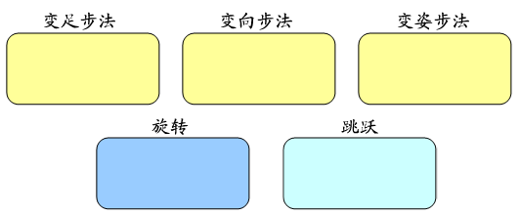
Execution /30 points，6 points per part

Speed /24 points
0-4 | 4-8 | 8-12 | 12-16 | 16-18 | 18-24
creativity/6 points

----------------------------------------------------------
Program Content Value /40 points score：+
Transaction  /10 points | Performance /10 points | Choreography /10 points | Music  /10 points
----------------------------------------------------------
Deduction score：-
Kick&No  slalomCones |  | fall |  | time
Execution include spin ,jump,footwork of change foot,footwork of change posture,footwork of change direction

