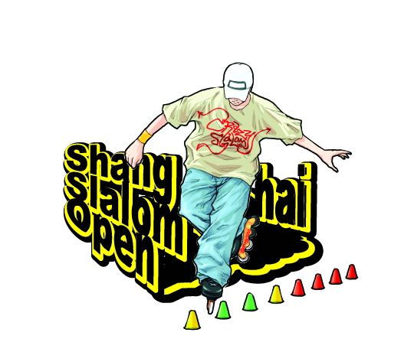
Preface
Shanghai, with its ancient past, dynamic present and exciting future, has the honour to host the Shanghai Slalom Open.

The city and its people are inspired by the Slalom spirit, confident of their ability to accept the responsibility for this great event and determined to commit their energy,passion and resources to the task.

Celebrating the Competition in Shanghai in AUG,2006 will afford a unique opportunity to inspire and educate a new generation of Chinese youth with Slalom values, and to promote the Slalom spirit and the cause of slalom sport in China and the developing world.

The age-old history of Shanghai has endowed the city with very rich cultural heritage. Contemporary Shanghai is culturally creative and innovative, and embracing of other cultures and traditions.

The Slalom Open in Shanghai will be a bridge of harmony between cultures and embody the slalomer’s unique integration of sport and culture.

Shanghai’s second host again has the full support of the Center of Society Sports ,State Sport General Administration,PRC,Chinese Roller Skating Association and Shanghai Sport Administration and is enthusiastically backed by Chinese people everywhere.

The commitment, capability and confidence of the people of China and Shanghai will deliver to the world’s slalom athletes and people a truly memorable Slalom Open in AUG,2006.
Introduction
【Shanghai Slalom Open】
Sponsor：Center of Society Sports, State Sport General Administration, PRC
Chinese Roller Skating Association & Shanghai Sport Administration
Organizer:Shanghai Huangpu District Government
Shanghai Huangpu District Sport Administration
Shanghai Roller Skating Association
Joint Organizer:Shanghai Roller Skating Club,66Club
Partner:Zhongshan Wanhao Sporting Goods Company Limited
Date: Aug,4th-6th,2005
Venues： 1、Shanghai Huangpu Roller Skating Building(SHRSB)
No.235 Dalin Rd,Huangpu District,Shanghai
2、Shanghai Bund (Open Ceremony&Pair Slalom,Morning, Aug,5th)
Zhongshan East 1st Rd ,Nanjin East Rd, Huangpu District,Shanghai
【Event Situation】
Invited Country & Area:France,Russia, Italy ,Germany,UK, Spain,South Korea,
Singapore, Japanese,China,Hong Kong,Taiwan,and others.
Slalom Athletes: according to Shanghai Slalom Open in 2005,the above invited slalom athletes who come to Shanghai will be nearly 200 skaters

【Schedule】
The general schedule is provisional and will be adjusted in accordance with the final program approved by the Organizer.

Date | Program | Venue
AUG,4th Morning | Speed slalom（CHN） | SHRSB
AUG,4th Afternoon | Freestyle Slalom（CHN） | SHRSB
AUG,5th Morning | Team Slalom（Int’） | Shanghai Bund
AUG,5th Afternoon | Speed slalom（Int’） | SHRSB
AUG,6th Morning | Freestyle Slalom（Int’） | SHRSB
AUG,6th Afternoon | Freestyle Slalom、Ceremony | SHRSB
【Rules&Regulations】 Published by Chinese Roller Skating Association

【Remark】
Venues
1-Shanghai Huangpu Roller Skating Building 2-Shanghai Bund
No.235 Dalin Rd,Huangpu District,Shanghai Zhongshan East 1st Rd ,Nanjin East Rd, Shanghai
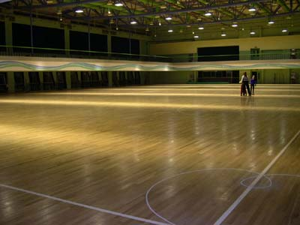
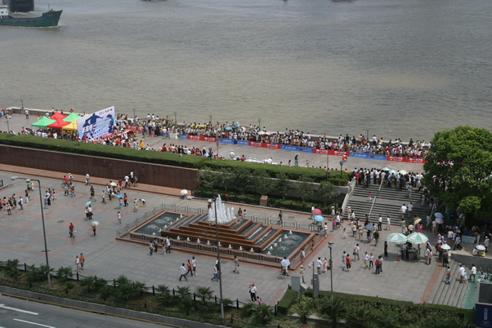

Visa
Please find more information from http://www.fmprc.gov.cn/eng/wjb/zwjg/default.htm

Airport
Please find more information from http://www.shanghaiairport.com/en/index.jsp
Conclusion
We have presented a conscientious and honest account of the commitment, confidence and capability of our people and Government to deliver a Great Slalom, worthy of the Slalom ideal.
Just as Shanghai will give a new and exciting Chinese cultural dimension to holding the Slalom Open, so will it bring its individual qualities and skills to preparing and organizing it.
We will work diligently to recognize the central importance of the slalom athletes of the world. We will guarantee them the best possible living, training and competition conditions in a great city and a clean environment. They will have every opportunity to perform at their best and inspire a new generation of young people in China and around the world.
We will work diligently to give the large numbers of Slalom spectators and
visitors to Shanghai an unforgettable sporting and cultural experience.
It is our sincere belief that the time is right for Shanghai to celebrate the Shanghai Slalom Open.

